Topic:
Impartial and Decentralized News

Author: Kevin R. Linera Hernández

Date: January 20, 2021

Check/Evaluate
- Verify if more people are being involved in politics, by checking census to see if the voting percentage has increased in Puerto Rico.
- Read reviews and experiences of people that have used the app.

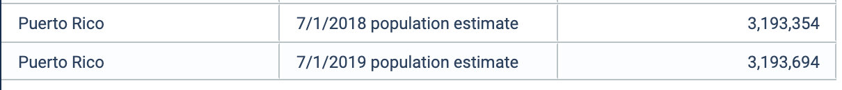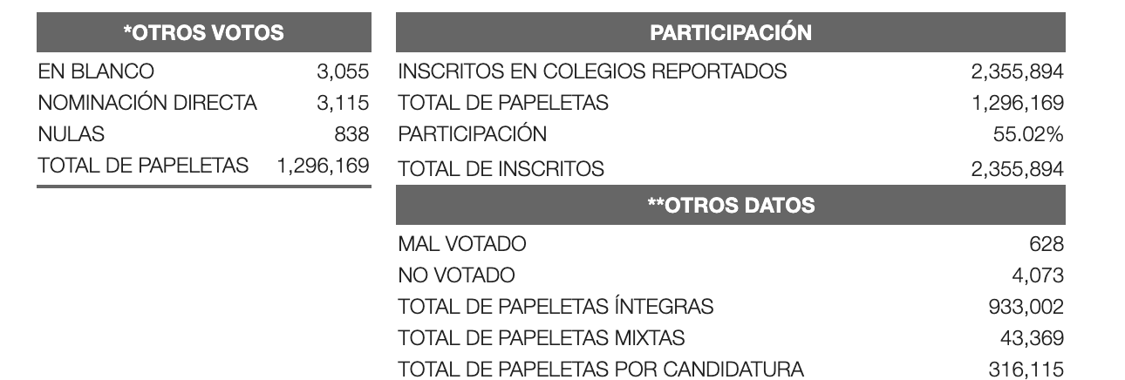
Causes:
One of the reasons is that the political and economic information is not being presented in a more explicit and impartial way. Where news outlets are being manipulated by political views.

Countermeasures:
- The main feature of the app is dividing news into categories, where the most important one is going to be highlighted to be more explicit.
- The app should make a final report, each month of the progress the present government has made.
- It should also state the pros and cons, that have happened over that period of time.
- In each category there are going to be links to different news sources. (Primera Hora, metro, ect.).
- The “Important” category will state the top news that should be seen to gain knowledge of the current situation of the country.
Act/Standardize
- Read suggestion of what other news outlets should be added to the portal/ web-application.
- Also, improve the UI, to attract more viewers to the page.
- Use different sources, to explore distinct point of view on the same topic.

Problem Background:
Voting is a right that not many people exercise in Puerto Rico. News should be shared in a more impartial way, where different news outlets are getting the chance to express their different point of views in one single place.

`
Target:
Increase the number of voters, by creating a web application portal that gives information of local news in a more organized and explicit.

.

